LG Software Architectures Training Program

Assignment A4: architecture views, behavior, microservices, ADR

Question 1 (30 points)

The diagram below shows the (simplified) design of an Internet Banking system.

Recreate the diagram to make it more expressive, so that the reader can understand better the nature of the components and connectors. Guidelines:

* Your diagram should show the same components (same names in the boxes).
* Consider that “Nationwide Bank Account Lookup” is a service provided by the Central Bank that can be accessed via the Web. Thus, this component is not a database and it’s not a local service.
* Add comments anywhere you think they’re necessary.
* You can make any assumptions beyond the (little) information the diagram provides.

Answer 1

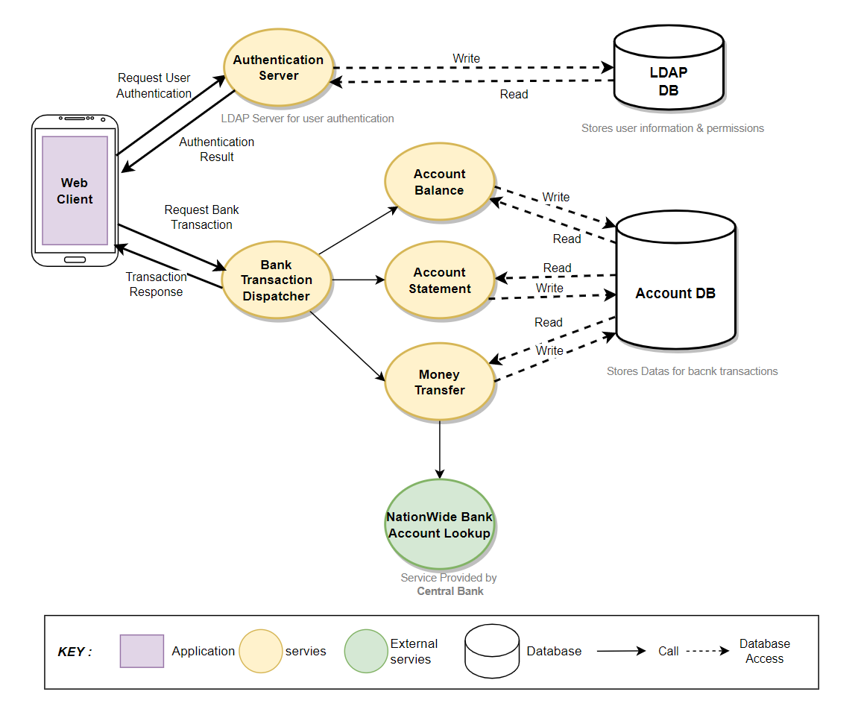

Question 2 (30 points)

Create a **state machine diagram** (only one diagram) to model the headlights of a traditional passenger car.

There is a switch on the dashboard with three positions:

* **Off** (the switch is in this position in the picture)
* **Running lights on** (middle position)
* **Headlights on** (right-most position)

There is also a lever on the steering wheel to activate the high beam. If you push the lever forward, the high beam is activated. When you pull the lever back to its original position, the high beam is deactivated. When in its original position, you can also pull, hold, and release the lever to activate the high beam momentarily—that is used to flash the high beam.

There is another constraint: pushing the lever to activate the high beam only actually activates the high beam if the switch is in the headlights ON mode.

Guidelines:

* As a simplification for this state machine, you should consider that the car is started (motor is running and the battery is working fine).
* Model the simple headlights system as described, do not include an "Auto" setting, DRL, fog lights, etc.
* You can make any assumptions beyond the information already given.
* Like in any state machine diagram, you should start by identifying the initial state. From there, for each state ask yourself what actions or events can occur when the machine is in that state. Then you create transitions for each possible action/event.
* Driver actions on the lever may correspond to state transitions. To avoid terminology confusion, please use the terminology indicated below to represent the lever actions.

**Answer 2**



Question 3 (10 points)

What is the constraint (main characteristic) of the Microservice architecture style that distinguishes it from the monolithic model of deployment?

**Answer 3**

**It is the physical separation of modules on a network. (Loose coupling)**

Microservice is a structure in which individual modules/services are run in a system distributed over a network, and functions are called and responded to each other through network communication between each service. Role-cohesive modules are loaded in systems distributed in a network, and configured, or sometimes replicated services exist to ensure system-wide availability. Therefore, when designing Microservice, it is necessary to separate them into lightweight services with functional cohesion and use an appropriate configuration or system to deploy them.

Because of this, Microservice has advantages such as deployment flexibility, availability, modifiability, scalability, development role management, and reusability. However, it has disadvantages such as performance (slower compared to single system call due to network call), resource usage, complexity of deployment/modification/verification, difficulty in service management, and increased security attack frequency due to deployment to multiple servers.

Question 4 (30 points)

In the team project, the client application has to interact with the server component for different things, such as user authentication. The communication between client and server shall be secure.

Create an ADR that describes your team’s choice for the communication protocol and the mechanism for secure communication between client and server. Guidelines:

* Use the ADR template available [here](https://github.com/pmerson/ADR-template). (But your ADR doesn’t need to be a markdown document; you can just use the structure in the template to define the subsections of the ADR that you’ll create inside in your A4 submission document.)
* You may write an ADR about the choice actually made by your project team or any other choice that you think is the best one.
* In your rationale discussion, explain why the chosen protocol and secure communication solution is appropriate. You can mention experiments, technical skills in the team, etc.
* Think of a second protocol that was a contender but was not chosen. Your ADR should mention it as a rejected alternative.
* The communication between client apps is NOT in scope for this ADR. This ADR is about the client-server communication only.

**Answer 4**

**ADR: Use OpenSSL library for session security**

One of the functional requirements is that client server communication must use a secure method. Session communications (Account and Call, Conference status) between client servers uses TCP and it is necessary to prevent others from collecting RAW communication data from Network.

**Decision**

* Use OpenSSL open source library for session security

**Rationale**

* We needed proper security integration method for windows development environment.
* We needed easy-of-use and well-known practice to use secured TLS communication method.
* OpenSSL is well-known and widely used open source library, and it was a relatively easy to find how to apply from internet.
* There was some of alternatives like **LibreSSL**, **BoringSSL**, **WolfSSL**, However, the team members had to use a well-known library that was easiest and quickest to apply and validate.
* OpenSSL also can be used to apply MD5 hashing algorithm to make user password data before send to server (Server will only save and compare MD5 hashed password in order to prevent the original password from being exposed even if the data is stolen)
* We did experiments to check implementation feasibility and result as below. (We’ve implemented basic session communication code and used **Wireshark** to capture TCP data in network)

|  |
| --- |
| **Experiment result**   * TCP communication without using openSSL      * TCP communication using openSSL |

* We’ve verified that TCP packet in the network to check if our implementation is working.

**Status**

* Accepted

**Consequences**

* Using **openSSL** open source library will fulfill the security requirement especially for sever client communications.
* We have to apply limited usage of TLS not using certificates from CA. (Design limitation considering the project schedule and background knowledges)